**Sutton Environment & History Group**

**Events 2020**

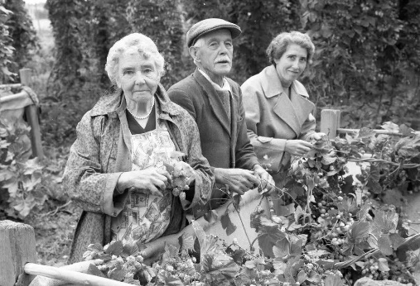

**Monday 10th February 2020**

**‘Stories from the Hop Yards’**

A Film by Catcher Media

Sutton Village Hall 7.30-9.30 £3.00 entrance for film. Wine, refreshments and raffle provided by Sutton Walls Conservation Group, so bring cash! All welcome

Enjoy a film about the hop picking days of the past, with a glass of wine and snacks. ‘Inspired by the rediscovered Derek Evans' photographic collection “Stories from the Hop Yards” brims with Herefordshire archive photos & films, alongside newly-recorded interviews.’ Refreshments provided by Sutton Walls Conservation Group to raise funds.

.

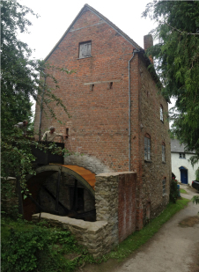**Thursday 9th April 2020**

**‘History and Restoration of Mordiford Water Mill'**

Andy Tatchell

Sutton Village Hall 7.30-9.00 £3.00 All welcome. Refreshments

A talk on the history and restoration of the mill at Mordiford, and the relevance of Water Mills on the Lower Lugg to flour milling

**Sunday 10th May 2020**

**‘Tour of Mordiford Water Mill’**

Tour & visit with Andy Tatchell 10.00-11.30. Donations to the mill. Meet at Sutton Village Hall at 9.30am. Visit to be followed by lunch at the Moon in Mordiford. Numbers limited, contact Judy Stevenson 01432 880748 [judy@creswells.co.uk](mailto:judy@creswells.co.uk)

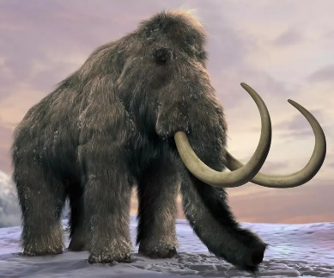

**Wednesday 1st July**

**‘Ice Age Herefordshire’**

Speaker to be confirmed

Sutton Village Hall 7.30-9.00 £3.00 All welcome. Refreshments

What was Herefordshire like during the Ice Ages? Were there mammoths or people in Herefordshire? Are there any visible remains?

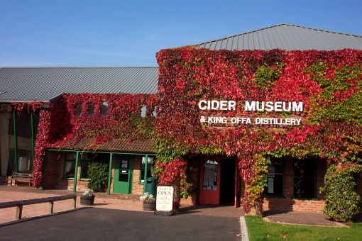

**Wednesday Sep 23rd 2020**

**‘Visit to the Museum of Cider’**

Visit and tour 2.00-4.00 £5.00 per person. Meet at the Cider Museum in Hereford at 13.50. Free parking available.

The Museum of Cider is kindly providing us with a free tour and concessionary tickets for our group. Tea shop open for tea and cakes after. Numbers limited, car share available, contact Judy Stevenson 01432 880748 [judy@creswells.co.uk](mailto:judy@creswells.co.uk)